**Ryan Hayes**

**E01304582**

**1. ATM Withdrawal Activity Diagram**

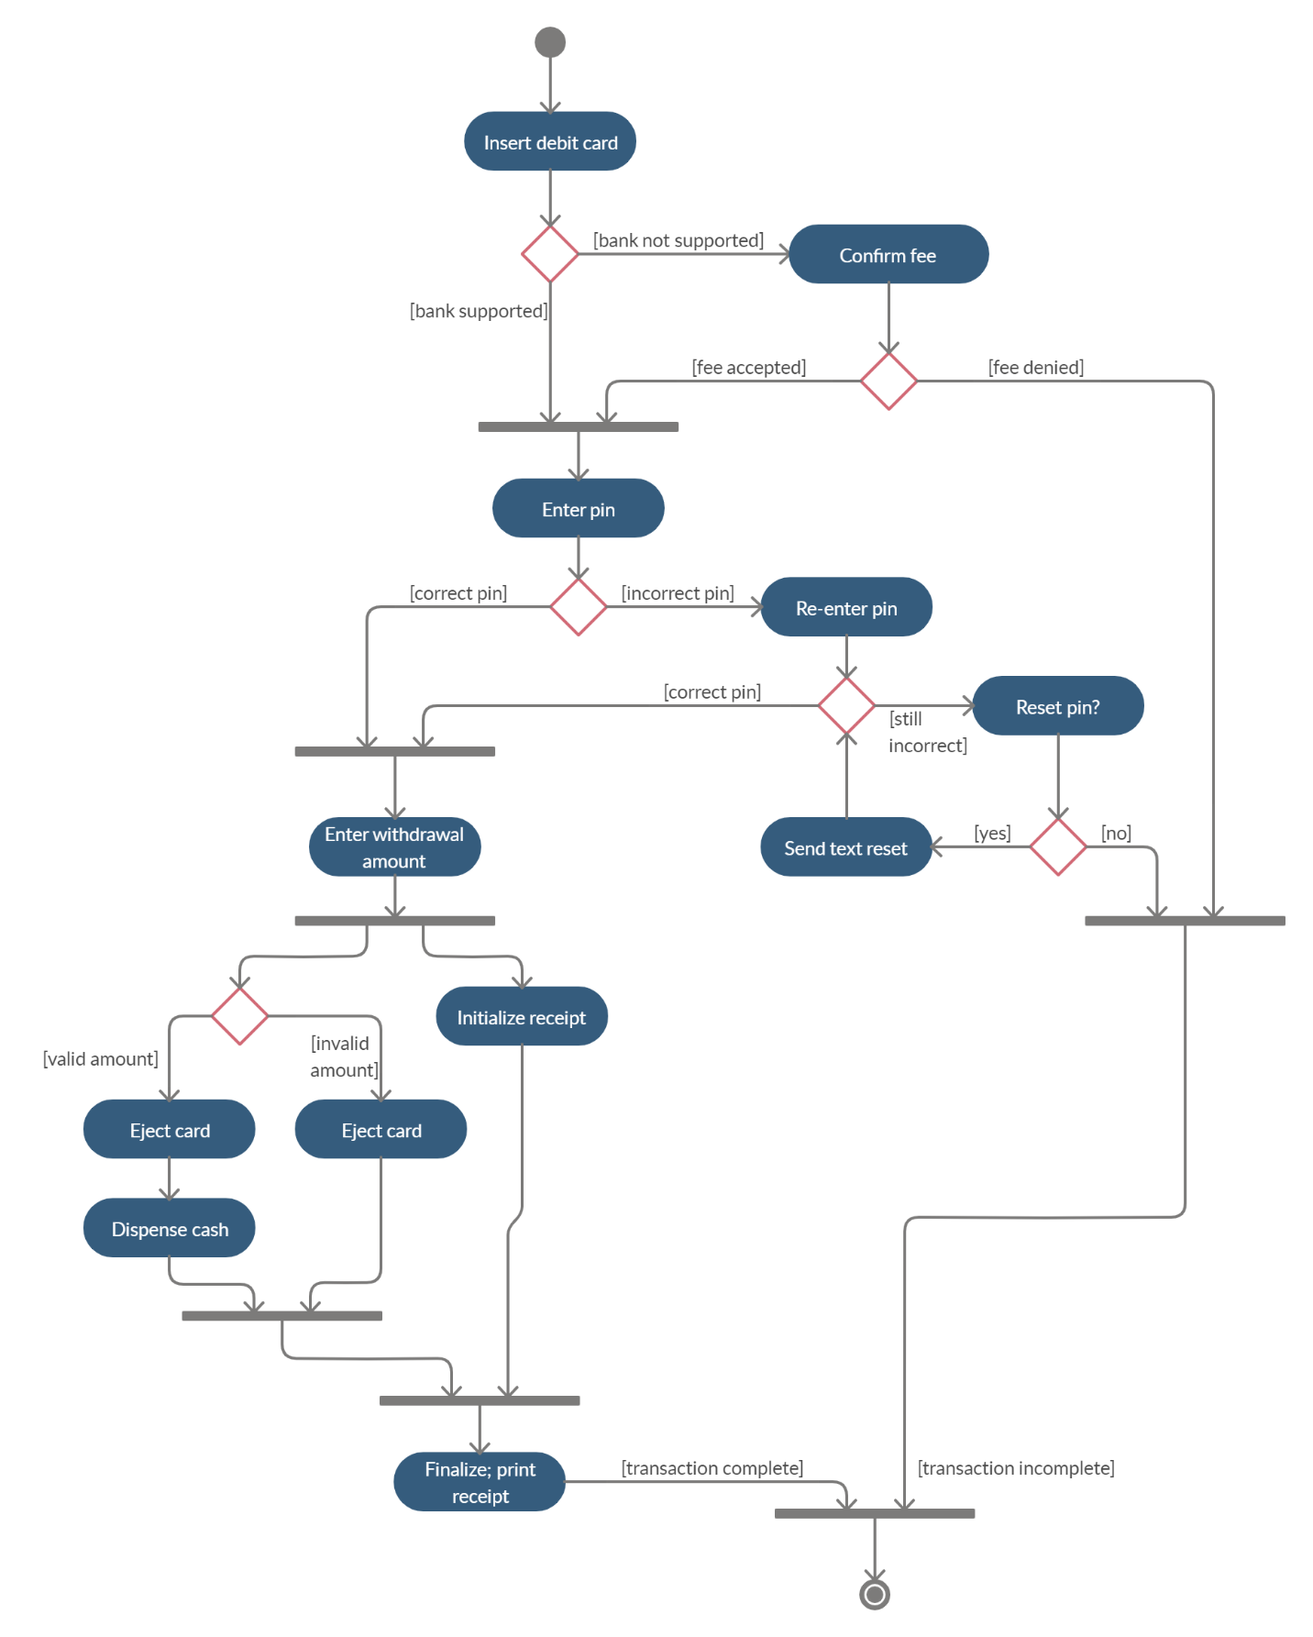

**2. ATM Withdrawal Sequence Diagram**

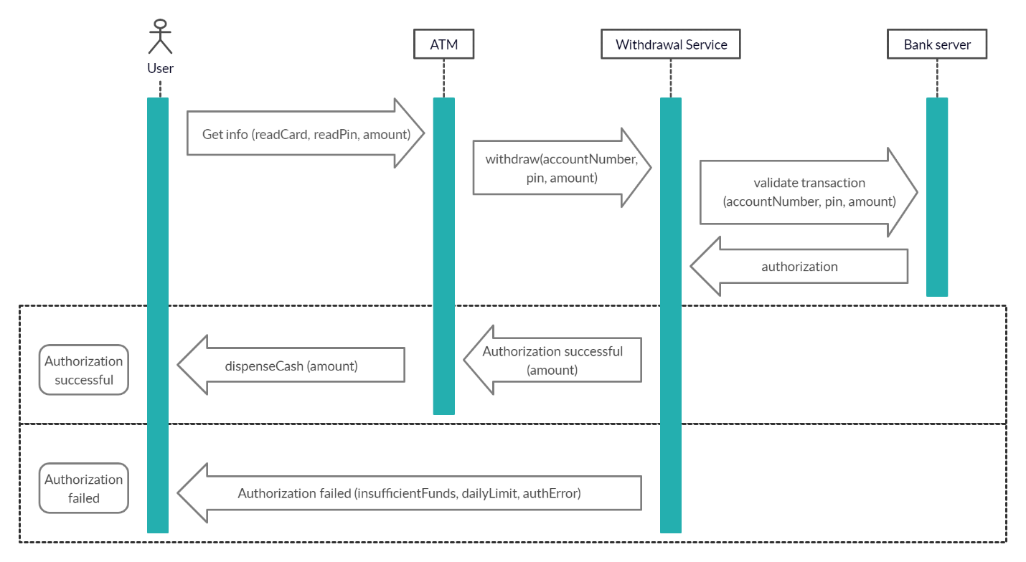

We may want to develop both activity and sequence diagrams for a system to help understand the flow of events better. The activity diagram will show the processes involved, while the sequence diagram will show the interactions between the system and its components. When implementing the system, this will assist us in determining which processes some of the components will handle.

**3. State Diagram – Top-load Automatic Washing Machine**

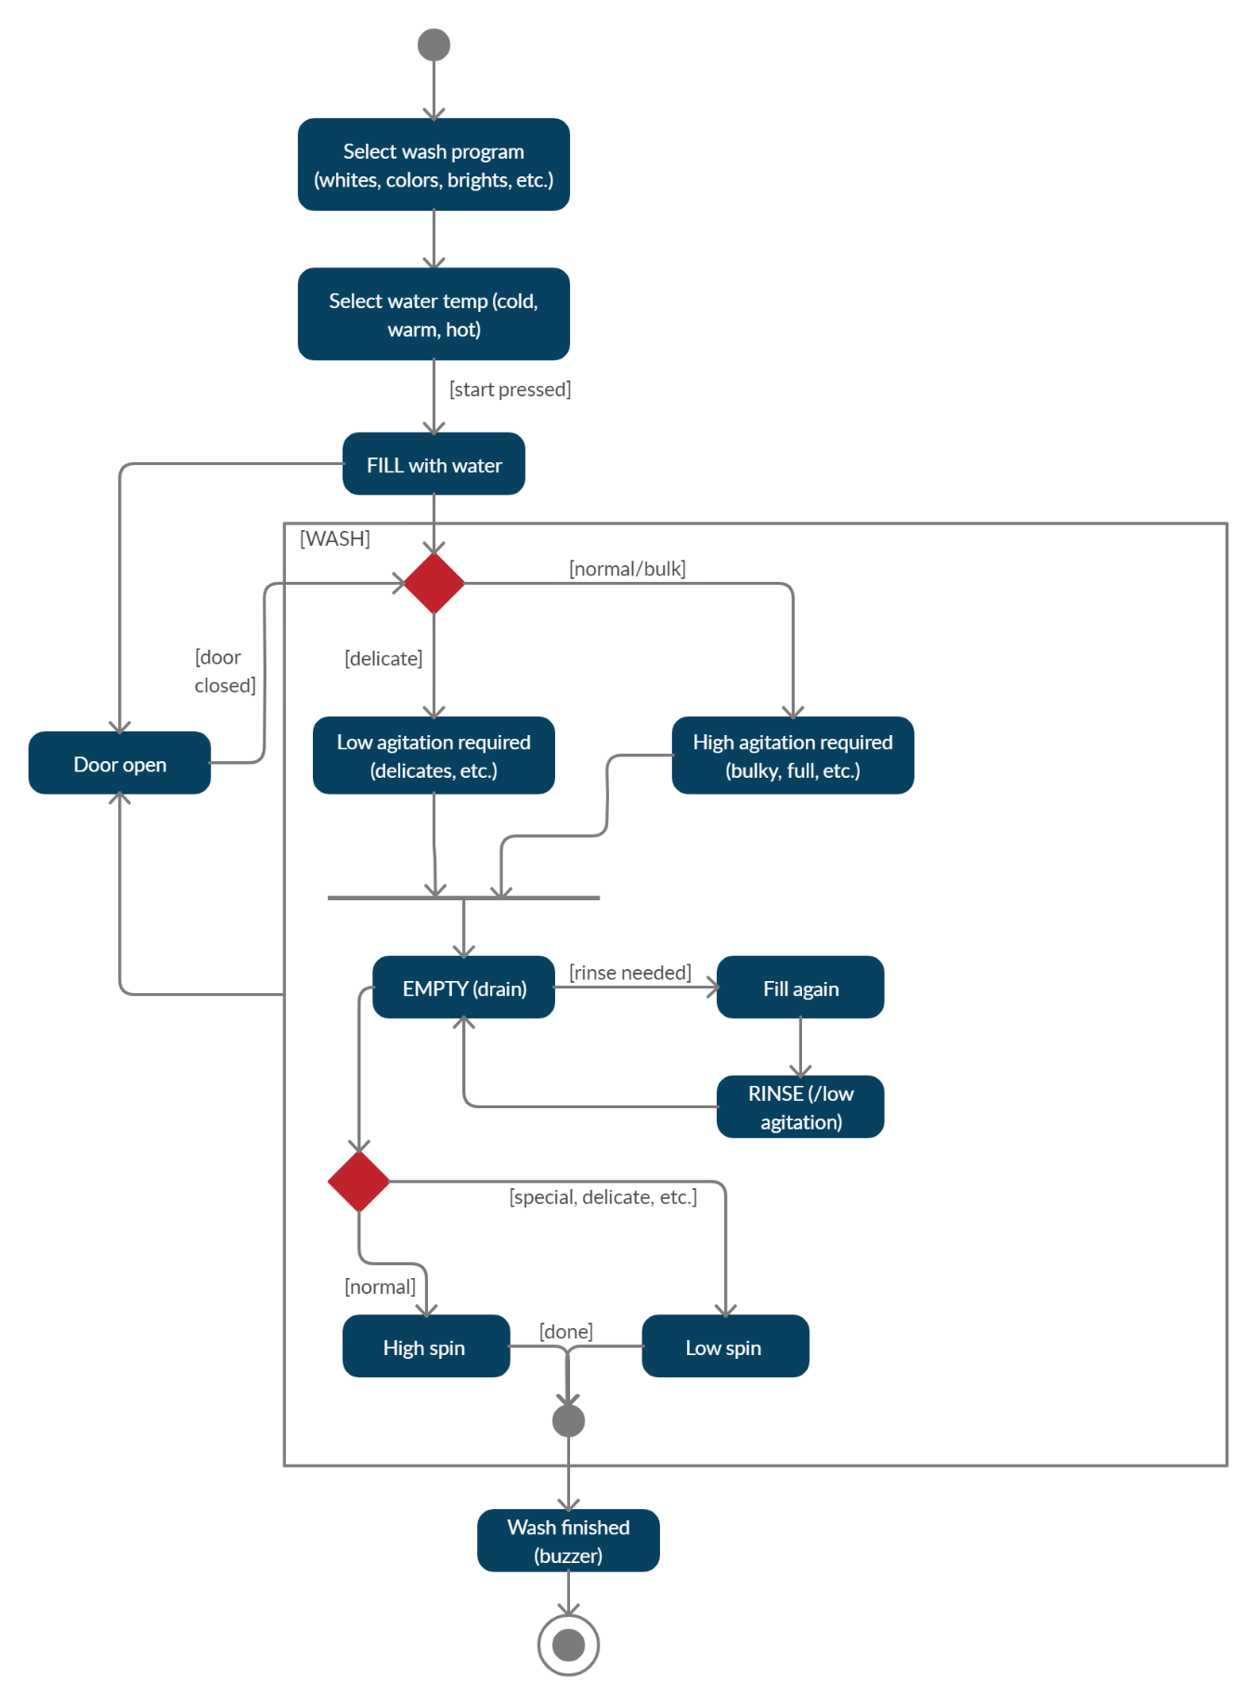

**4. Architectural Views**

*4A. Conceptual/Process View of Computer-Controlled Video Conferencing System*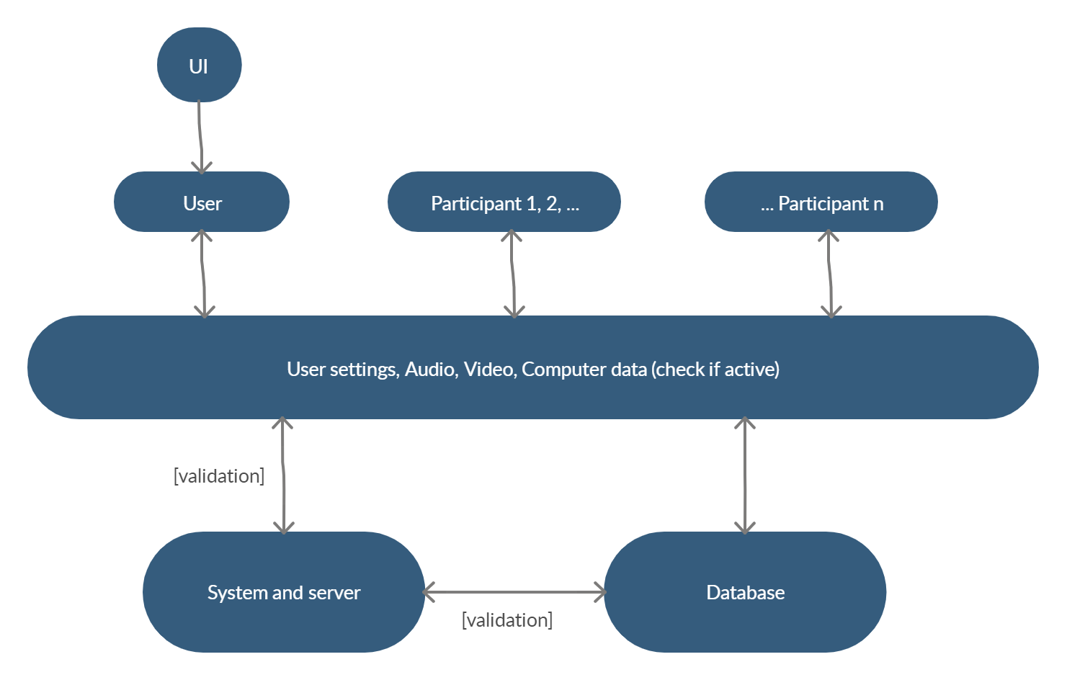

*4B. Conceptual/Process View of a Robot Floor Cleaner*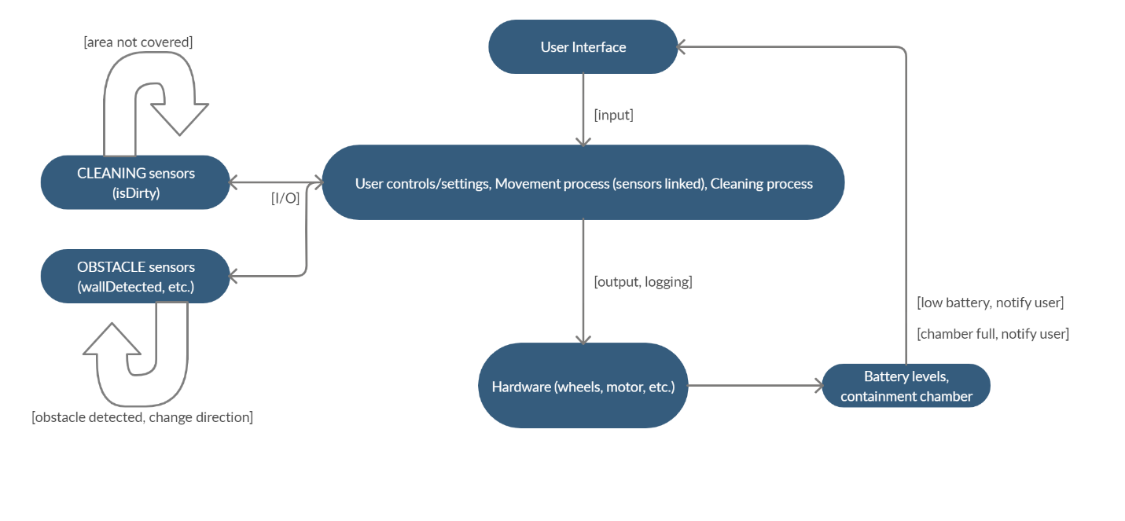

**5. Basic Information System Model – Flight Information app**

